Practicum Case | 
COMP7116 | COMP7116001 | COMP7116016 | MATH6168 | MATH6168016
Computer Vision
Computer Science | O221-COMP7116-WB01-01
Valid on Odd Semester 2024/2025 | Revision 00

Learning Outcome
- LO1 – Describe various computational principles and standard image processing operators in computer vision

Topic
- Session 5 – Feature Detection

Sub Topics
- Corner Detection
- Corner Visualization
- Threshold

Soal
Case
WheckerBoard Recognizer
We all know about the Checkerboard pattern. We already see it everyday, it consists of pixel square that usually have monochromatic colors. One of the example is when we playing chessboard, and when we are using flannel that have checkerboard pattern on it. You as a high-interest programmer wants to make a Python program that can detect each corner or square in the checkerboard pattern using SubPix, FAST and ORB algorithm.
- SubPix
- Make a program to identifies each corner or square of the checkerboard pattern using SubPix that will have their own centroid, which is an improvement of Harris Corner Detection Algorithm. Make sure to use the assets given on this case.
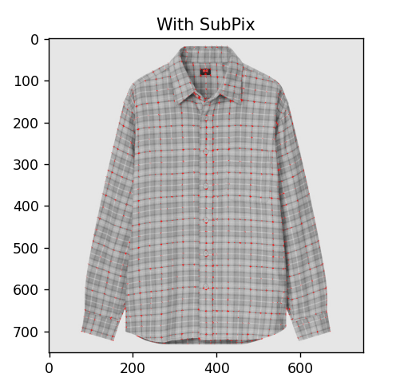
Figure 1. Example of using SubPix Algorithm

- FAST and ORB Algorithm
- Make a program to identifies each corner or square of the checkerboard pattern using both FAST and ORB algorithm. Make sure to use the assets given on this case. Don’t forget to plot all the results side by side, so we can compare them.
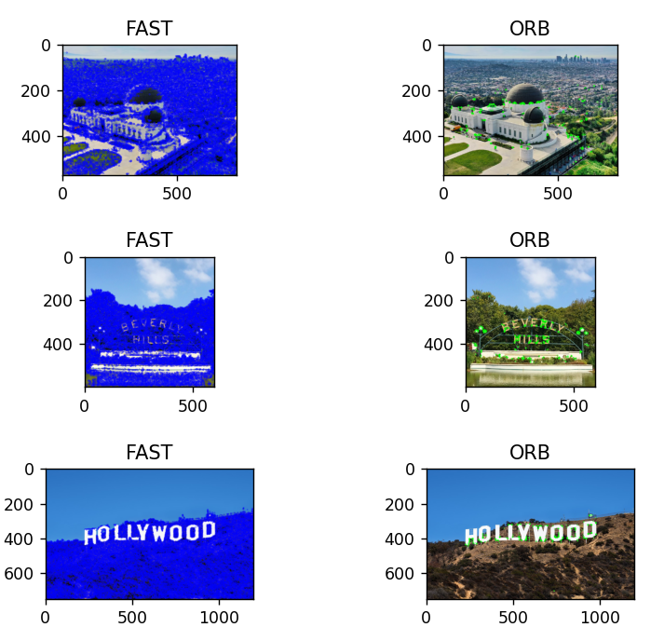
Figure 2. Example of FAST and ORB Algorithm Plotting

